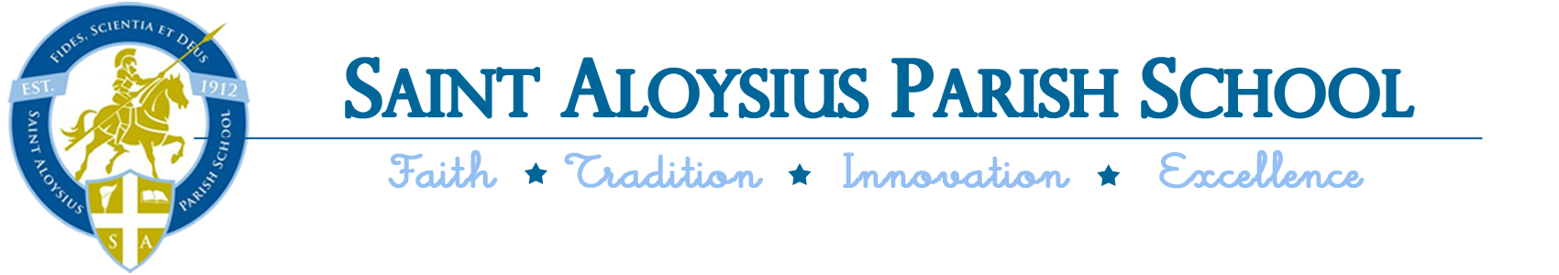

PreK-4 Supply List 2019-2020
Mrs. Shych’s Class
- A backpack, labeled with your name
- A lunch or lunch money/ticket
- A family photo
- 2 small individual photos
- A change of clothes in a labeled bag
- A blanket and small pillow in a labeled bag
- A roll of paper towels
- A container of anti-bacterial wipes
- A pump bottle of hand sanitizer

